September 2020
Setnor School of Music Source-Connect Standard Installation

WHY DO I NEED THIS?

Source-Connect Standard offers peer-to-peer audio streaming software with high quality and low latency, enabling synchronous remote musical activities.
What does this all mean? You can run Source-Connect between two users and they will have a clear audio connection. Choppy audio, begone! Users will be able to perform together in real-time in a virtual environment that is as close to the in-person real deal as we can get. Of its many uses, this software can be used to run concurrently with Zoom (audio muted), allowing for high-quality sound in online lessons and chamber rehearsals.
HOW TO INSTALL PROCEDURE

**********************READ BEFORE INSTALLING****************************
If you have not installed the iLok license manager AND been instructed on the procedure to acquire your Source licenses. STOP HERE and contact your designated technical support person. You will not be able to run Source-Connect without the iLok manager and the appropriate Source-Connect license installed on your computer.

1. Download the appropriate Source-Connect Installer for your operating system HERE.
NOTE: In most instances Setnor Source-Connect users are installing the Source “Instrument Suite” which includes Source-Connect Standard and for Mac users Source-Live Pro. Installation and use of Source Live Pro (mac only) is covered in other documentation.

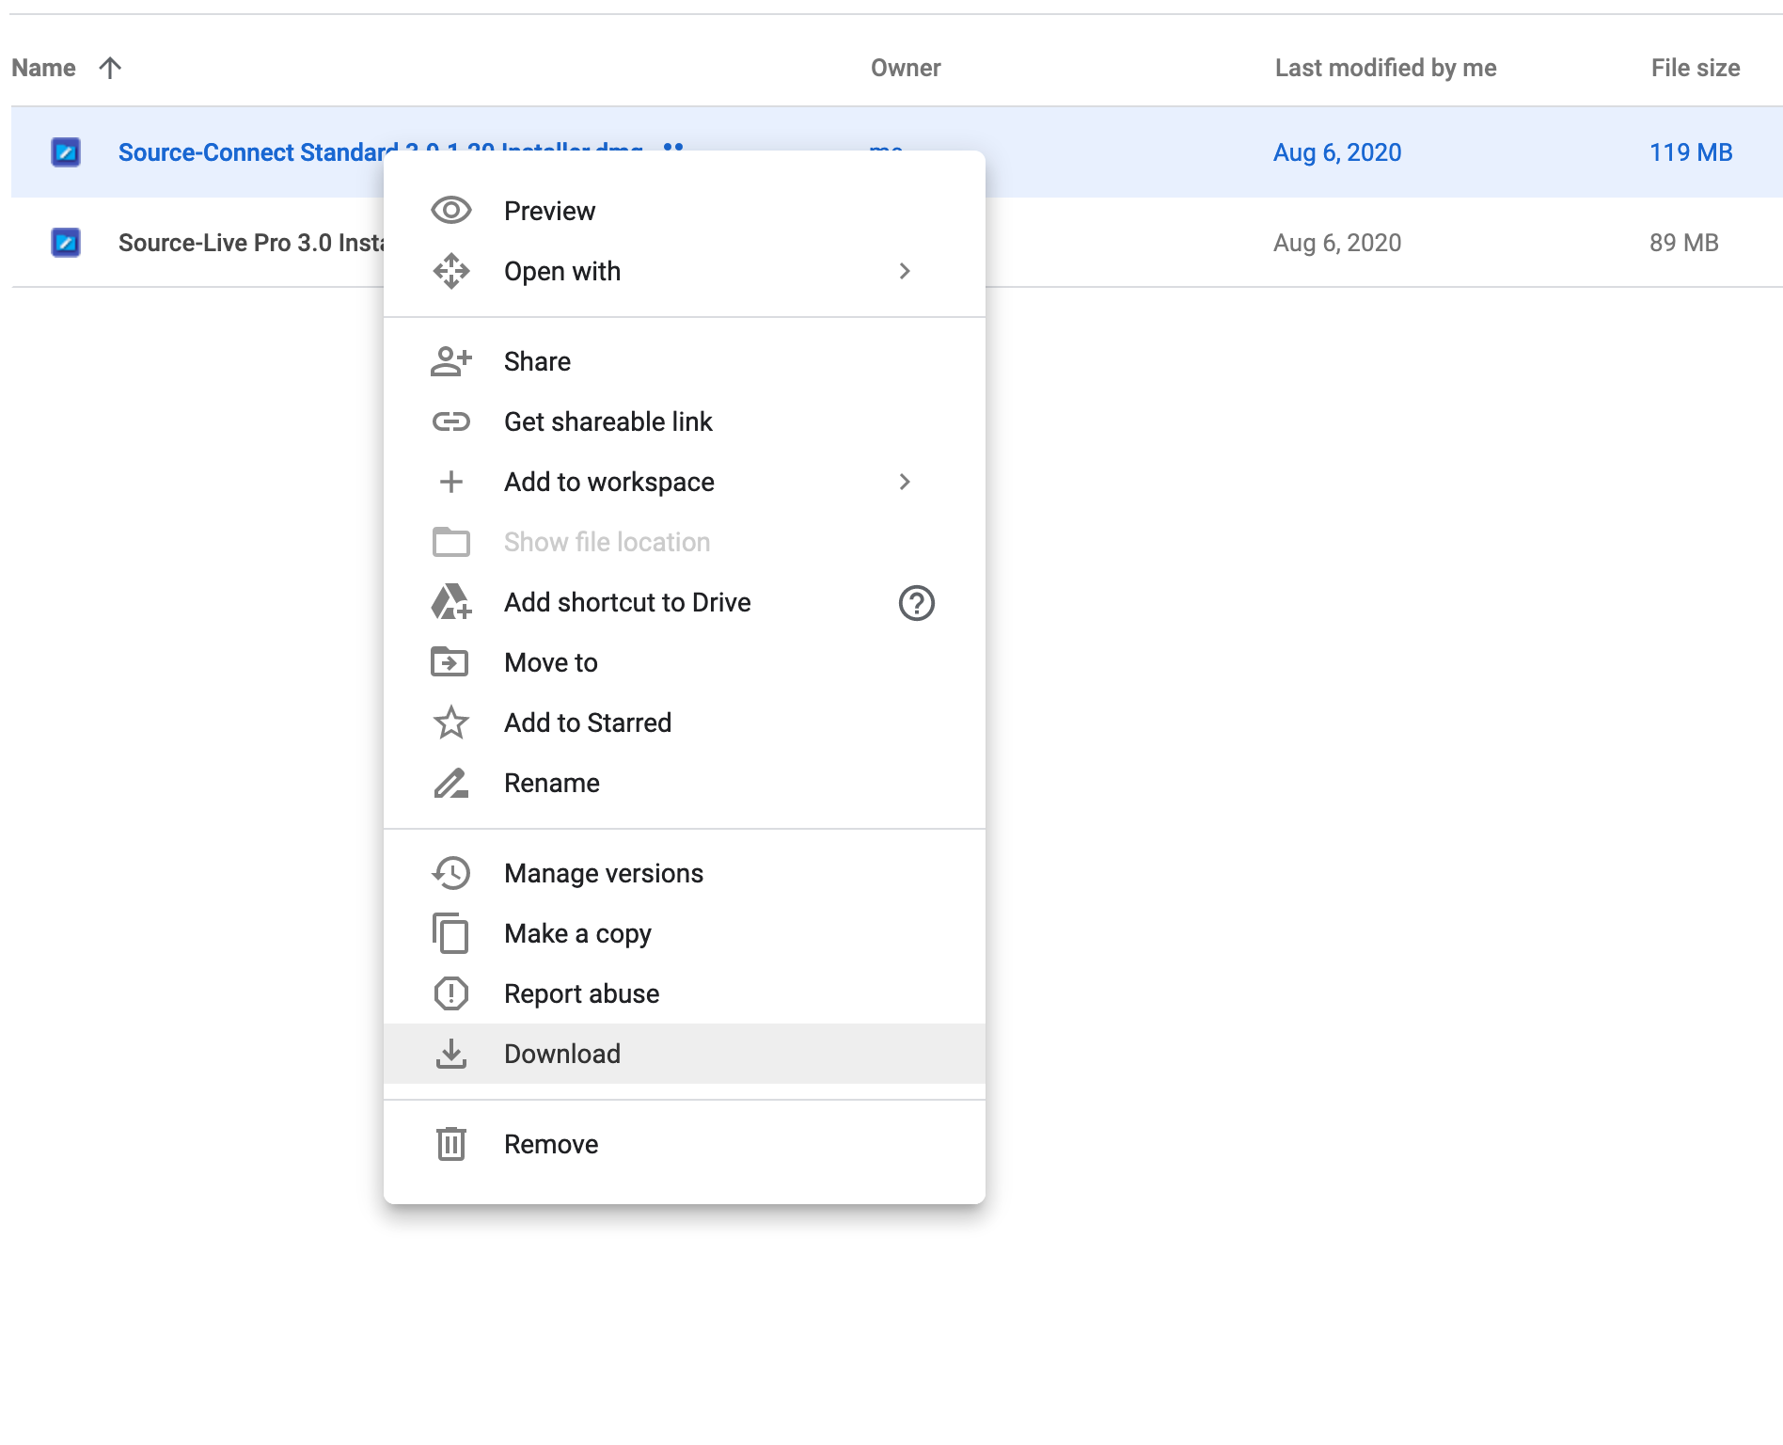
2. Navigate to where your Google downloads are stored (typically a folder called “Downloads”). Double click on the file “Source-Connect Standard 3.9.1.20 Installer.zip” or “Source-Connect Standard Installer 3.8.1 64-bit.zip” to decompress the file.

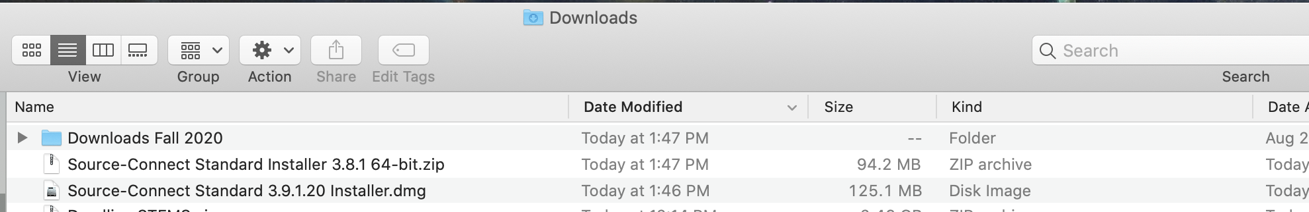

3. After the file is finished decompressing, double click on the file named “Source-Connect Standard Installer” to start the installer (Windows similar). When you see the window pictured below, click Continue and follow the dialogs to install Source-Connect Standard on your Mac or PC.

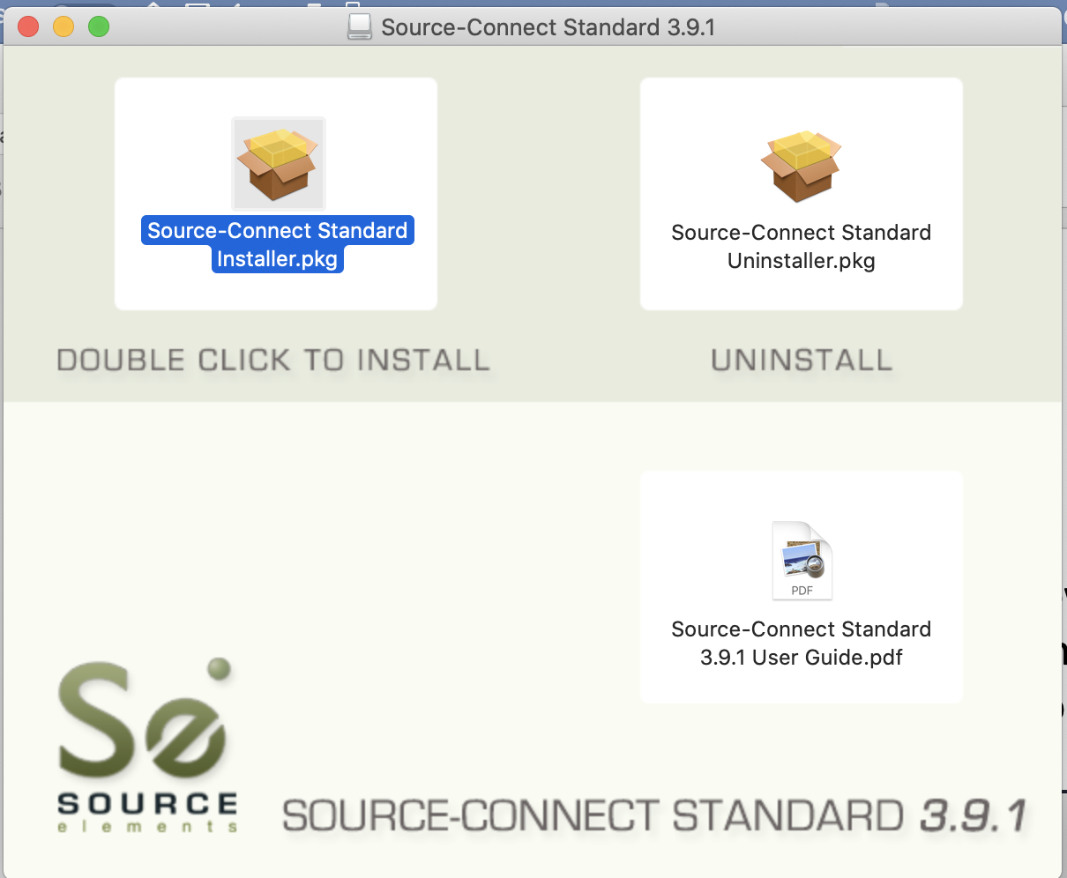

*MAC USERS NOTE: If you have Mac OS Catalina on your mac, you may need to bypass your system security settings to install Source-Connect. If you hold down “control” on your mac, a menu will pop up allowing you to open the installer, and the “open” option for the installer will be available to you.

Hold down control while clicking.
Select “Open”
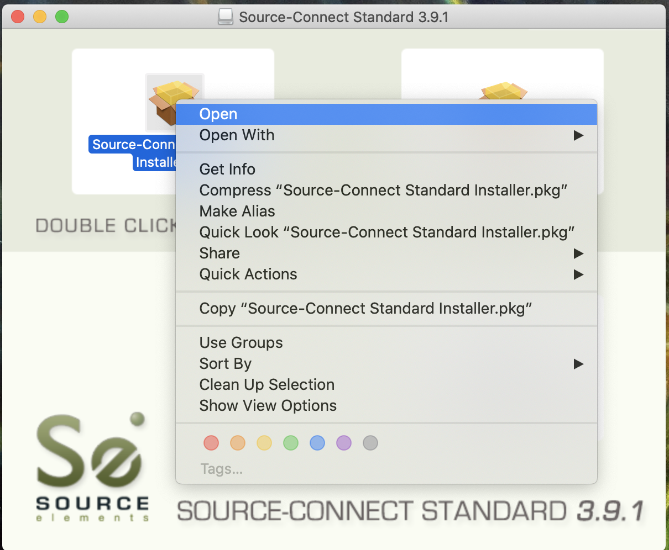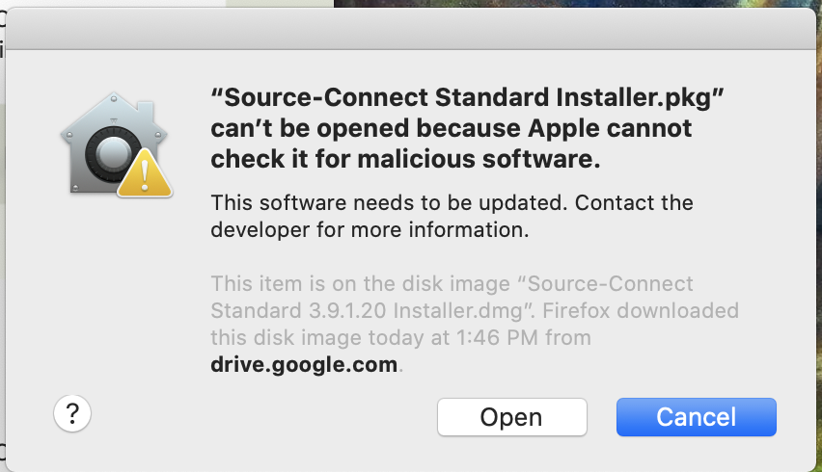
Don’t worry, Source-Connect is NOT malicious, click “Open”
4. Navigate to your applications folder and find the Source-Connect Standard application.

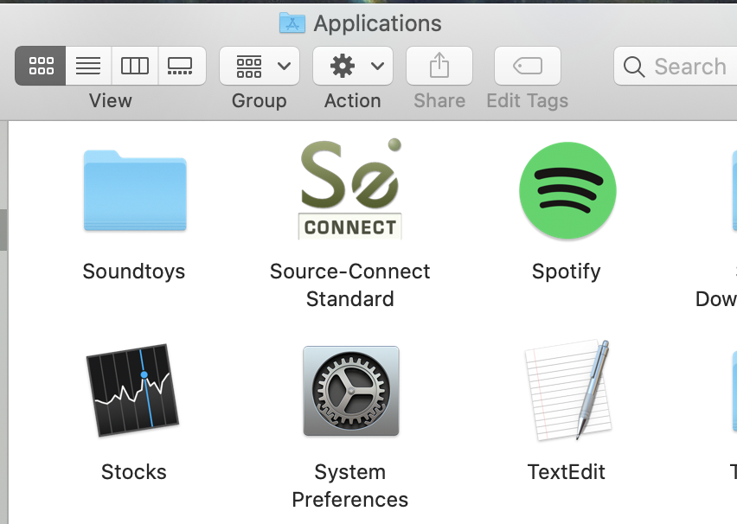

5. Double click on the Source-Connect Standard application to confirm it was installed properly. Everyone in Setnor has a username that follows the convention syr_firstname_lastname enter that in the “username” field. The password when you first log in is “Password” (note the capital P) You can use the default password, but it is recommended that you change the default password before you start using SourceConnect. Click on “Go to Online Account”. Your browser will take you to the SourceElements web site.

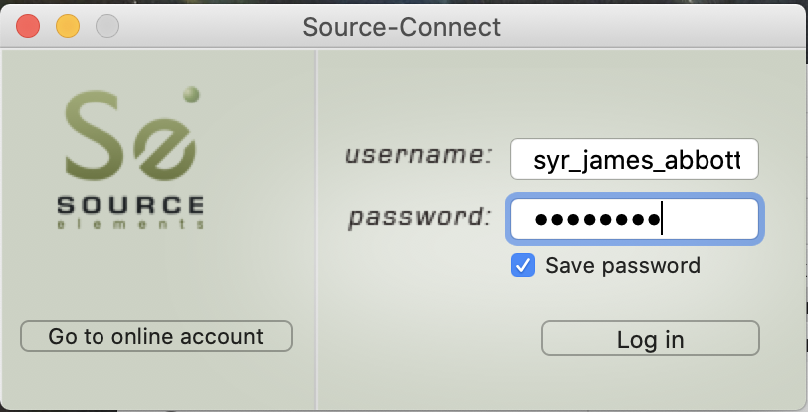

6. Sign into the SourceElements website with your username and the default “password”.

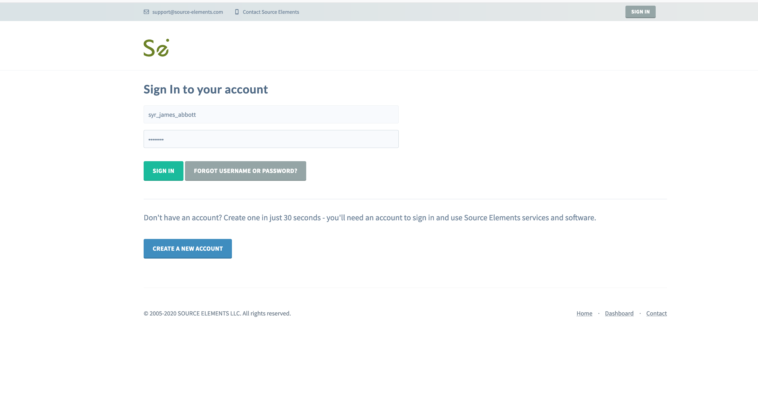
7. Click on “Profile” and something like the following web page will appear. There are many settings you can change (you will see I changed my avatar), for now we are going to change the default password and your profile visibility to make your username visible to other users and change your default password to one of your choosing.

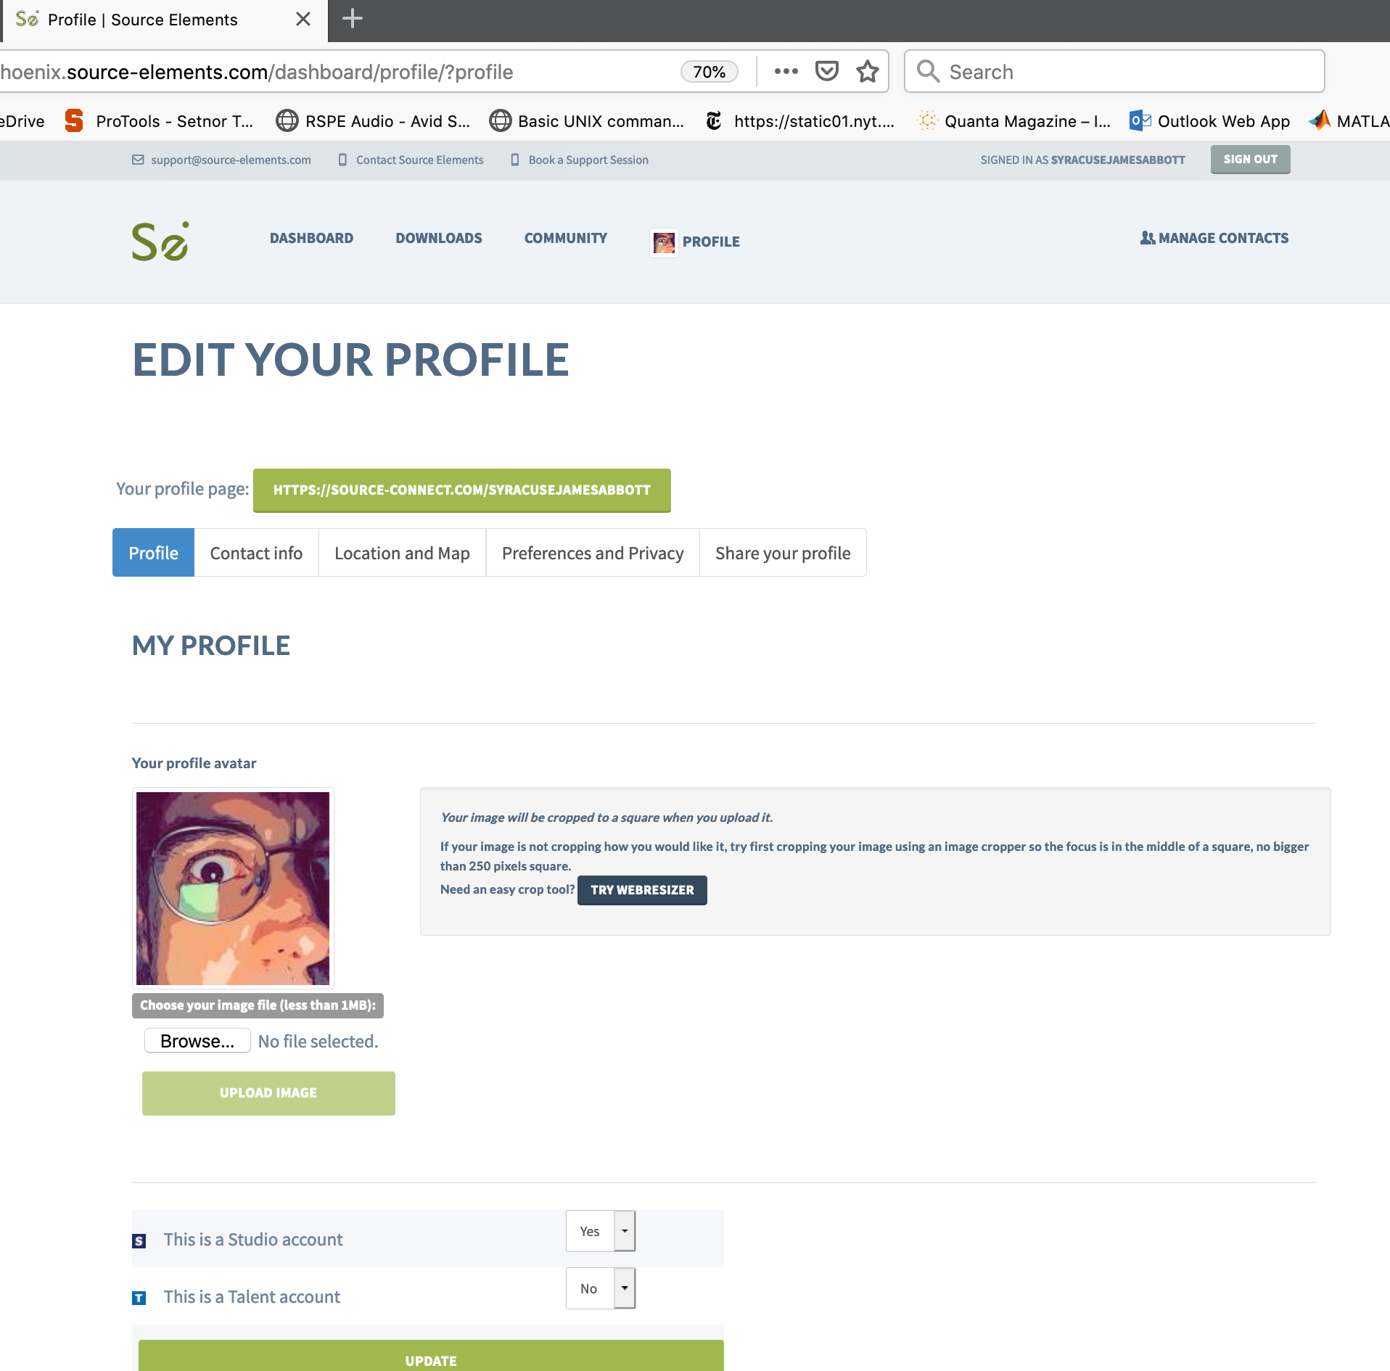

Click on “Preferences and Privacy”
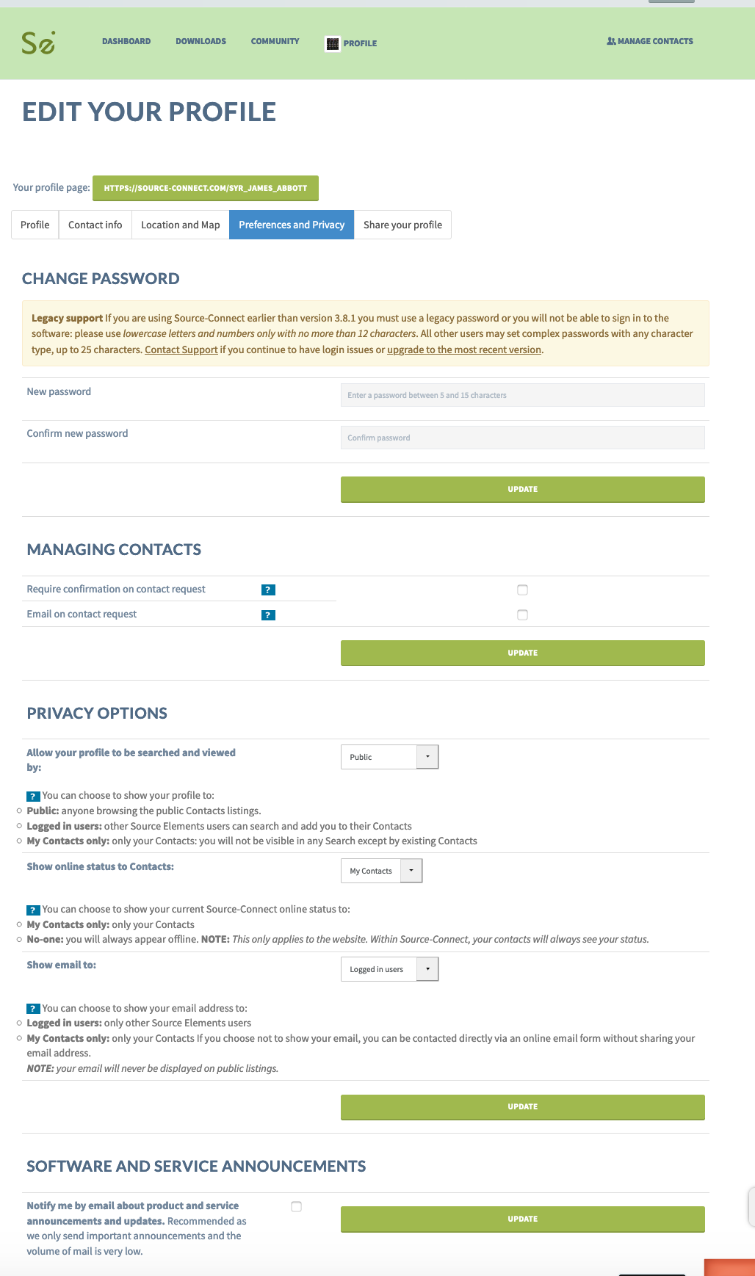
From here you can update your password and choose how other users “see” you when you are using Source-Connect. In my case, I allow my profile to be searched and my email address seen by logged in SC users, and only show my online status to my contacts. I don’t require a confirmation on contact request, nor an email on contact request. These settings seem to work best. Don’t forget to click “UPDATE” to save the new setting before you leave the page. Do this on each “update” button, even if you did not change anything so the settings are persistent.

The next page shows you how to search for and find other people that are on SourceConnect.

7. While you are logged into your SourceConnect profile, click on the “Manage Contacts” link in the upper right-hand corner of the website. Something like this window will appear:
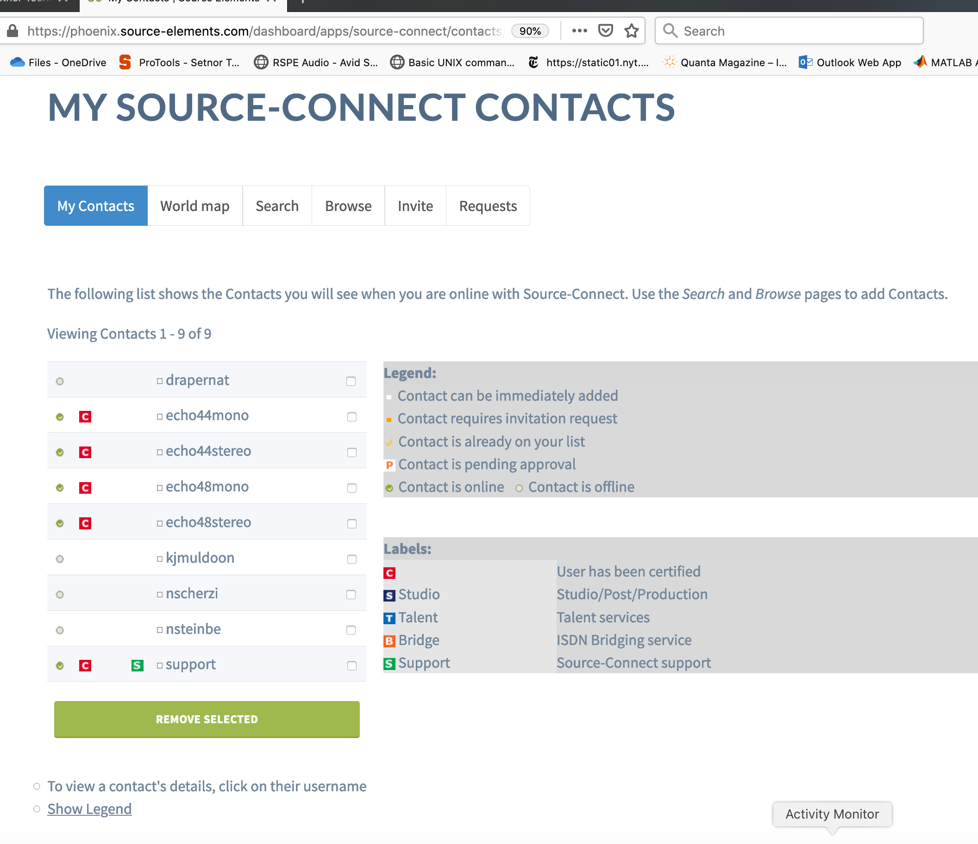
8. Click on “Search”. Remember, everyone in Setnor has a username that follows the convention syr_firstname_lastname. As long as the person you search has made their profile “public” you should be able to find everyone in Setnor by “Searching by Username”. For example, if you search by Username “syr_james_abbott” you will find my profile, as in the second image. You can then select the user and add/invite them to your contacts. If you would like to find EVERYONE in Setnor, search Username “syr_” which is the prefix before everyone’s username in Setnor.

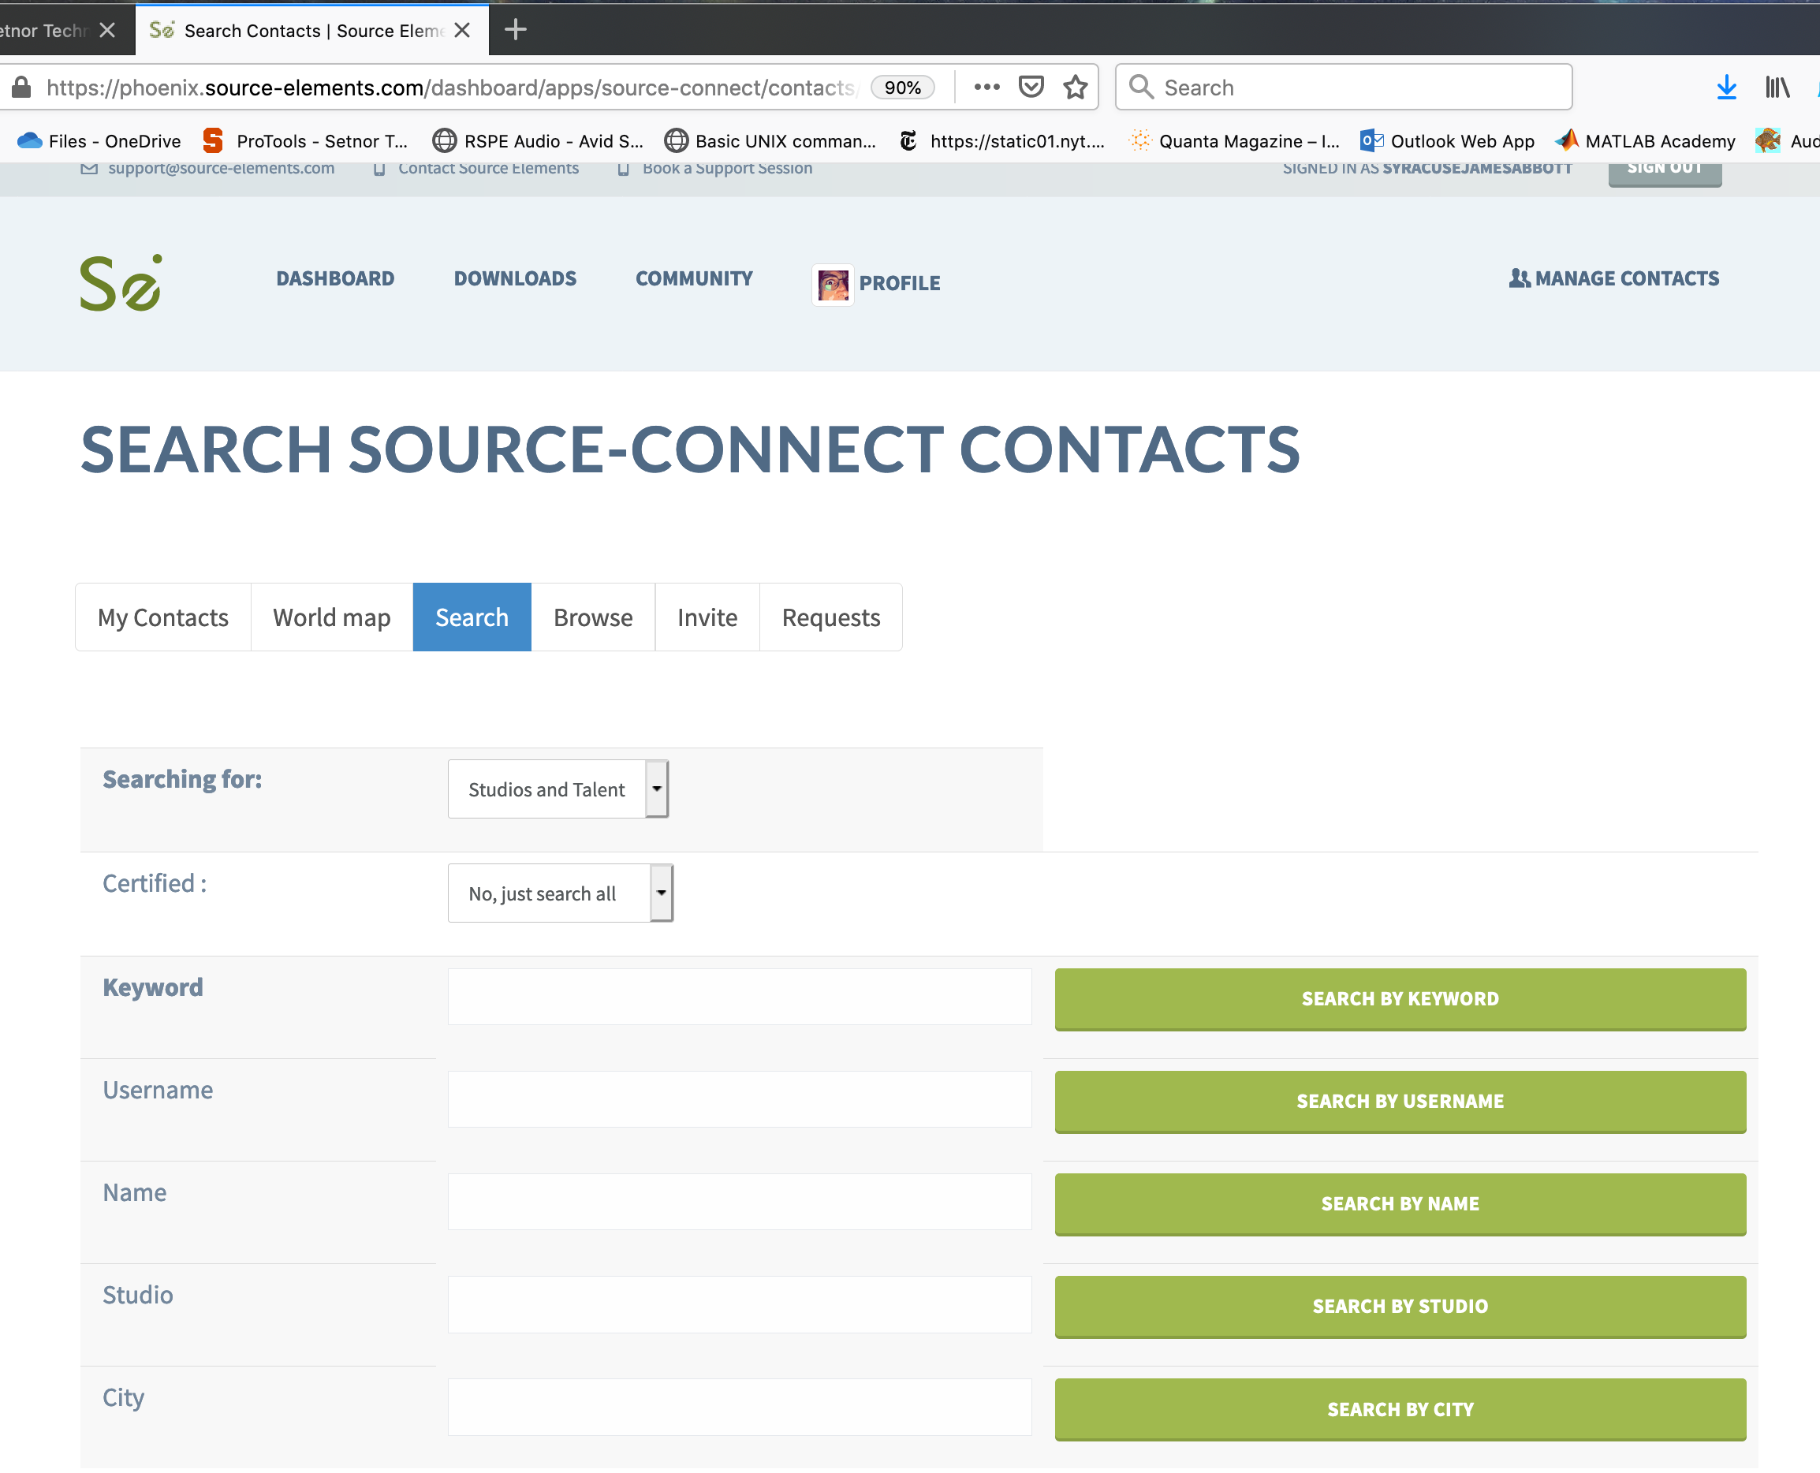
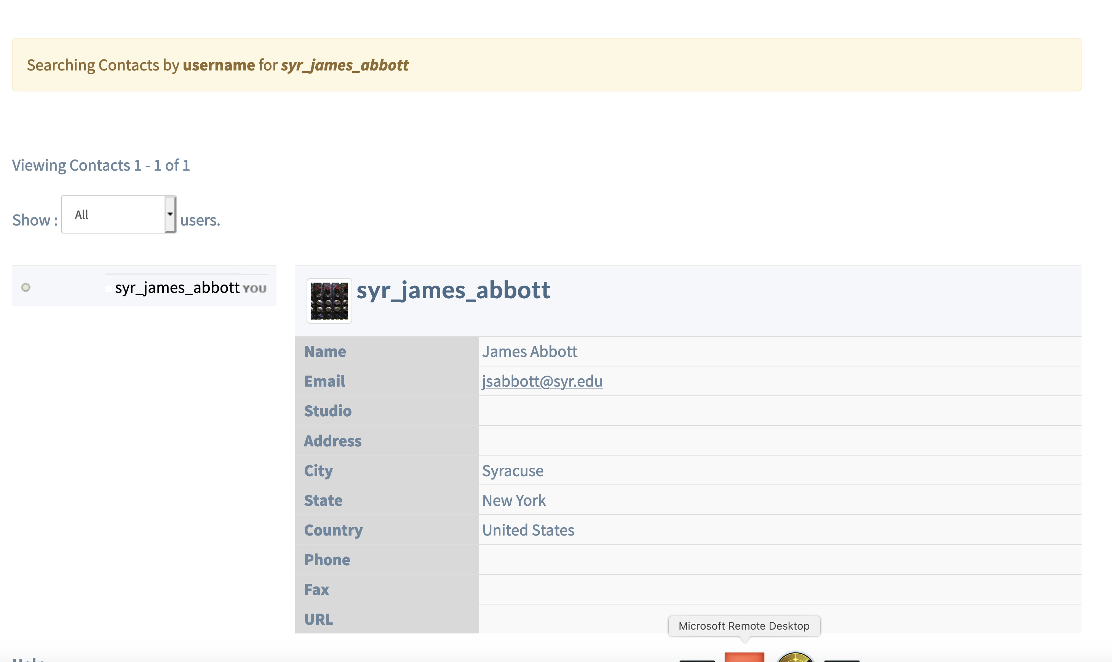
6. Now we are ready to log into SourceConnect with your new password and get to work. Go back to the Source connect application (re-start it if you quit it).

Enter your username and new password and Click “Log In”.
Something that looks like the following window will appear:

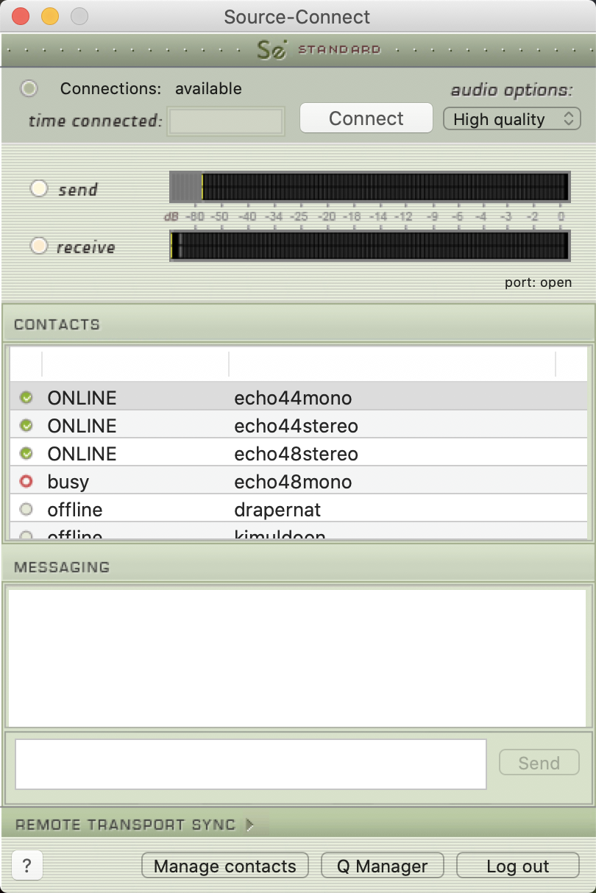 YOU ARE IN!

